Remote Training SOP
As early as possible:
Create agenda
- Update the time, logos, and trainers
Create Zoom meeting
- Make a reoccurring meeting
- Make sure waiting room is enabled
- Have confirmation emails sent to you
Create a registration form
- Using your preferred platform, create a registration form
  - Collect name, contact info, shipping address, and occupation
- If using CAP money to supplement training material costs, have a discounted rate for in-state participants and charge out-of-state participants the cost of the manual and certificate.
- Close registration 1 week before the training date or when you class fills (we suggest limiting to 20 participants)
- Determine if you will allow FDA to register and how many seats you will allow them to fill
- We allow 5 county extension agents to join the training in addition to the 20 participants
  - Rather than having agents fill out the form, I have them just email me if they want to attend since we do not charge our agents.
Advertise Training
- Create a save the date flyer and other promotional graphics for social media
- Share the flyer via social media, constant contact, email to county agents and email to the State Department of Agriculture.
Register with AFDO
- Register the training with AFDO
- Email Michele C. Humiston mmc15@cornell.edu to ask her to put the training on the PSA website (send her the registration link)
Three weeks before the training
Order Manuals
- Three weeks before the training, place an order for training manuals from PSA.
  - Have manuals shipped to all participants that have registered so far.
  - Since registration is open for 2 weeks after the order is placed, order extra manuals to be shipped to you. If more people register for the training, you will then be able to ship them a manual. (I order 25 manuals total with all extras sent to me)
  - Ship manuals to be delivered at least 1 day before the training as necessary
Two weeks before the training
Zoom Test Meetings
- Email all participants to schedule a time to test Zoom technology before the training. I provide them dates and times that I am available and ask that they reply with 3 options that work for them. Schedule individual Zoom meetings with them.
  - Make sure their camera is working and they know how to mute/unmute and chat.
  - Send the training Zoom registration link to them through the chat and ask them to click the link to register
  - Send the evaluation link through chat and verbally explain how the evaluation works and that they must submit one.
  - Set expectations: camera on, present the whole time, be prepared to engage through chat, polls, and unmuting
One week before the training
Follow up email with participants
- Email all participants to remind them of the training. Include:
  - Training date(s) and time
  - Zoom registration link
  - Evaluation link
Polls
- Email all trainers and request poll questions (no more than 5 per module)
- Enter polls into the Zoom meeting (There is a limit on how many polls can be entered. You may have to load the first half of the modules, complete the first half of the training, and then delete those questions and load the rest of the questions.
Trainer test meeting
- Schedule a test meeting with all trainers
- Make sure everyone can share their screen and volume works (if playing a video during a module)
- For each module, select one person to teach, one person to moderate, and one person to monitor the chat. We have one person monitor chat (respond to questions or unmute to ask the teacher a question from the chat) for 2 modules in a row. We also have one person moderate per day (we split our training into two days. Example:
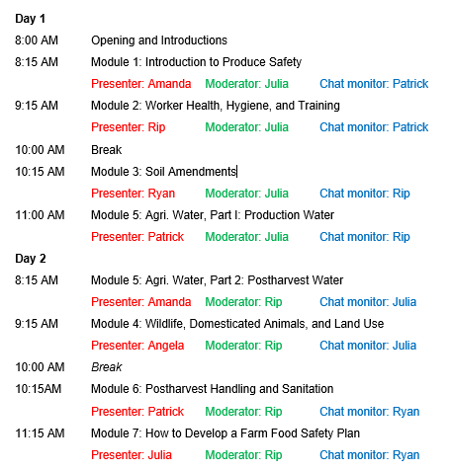
- Decide how early to be on the Zoom meeting before the training starts (30 minute recommendation)
Post Training
Submit Attendee Worksheet
- Fill in Attendee Worksheet (Excel) and Grower Training Invoice (Word) and email to AFDO at afdo@afdo.org. List the lead trainer as the instructor on the Grower Training Invoice. Be sure to only include people that completed the training that were attending to obtain a certificate on the Attendee Worksheet. They must finish the entire training to be eligible for the certificate. Partial completions will not get a certificate, even if they paid for it. Put course number in the title of the email.

